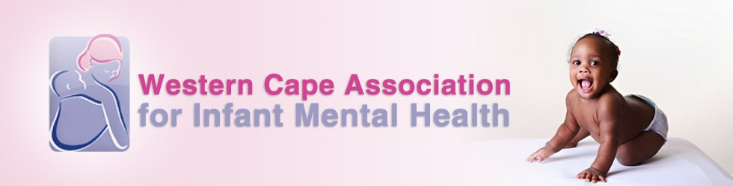

OCTOBER NEWSLETTER

Warm greetings to all our members and those newly on our mailing list. It is hard to believe that there are only three months left of this year, and only two more WCAIMH meetings!

Last month we had a wonderful presentation by Judy Davies, a long-standing contributor to our group. Judy shared with us her vast experience and expertise in the field of infant observation and led some thought-provoking discussions on the strengths and challenges of this particular practice. It was clear that there is much to be gained for the practitioner, including many opportunities to practice the art of “sitting with discomfort”! We are, as always, very grateful to our speaker for sharing her time and wisdom with us.

In October, we will be welcoming another highly respected professional who has been in the field of infant and child mental health for more than 40 years. **Dr Karen Kaplan-Solms** is a clinical psychologist with specialisations in neuropsychology, developmental studies, otoneurology, and occupational medicine and epidemiology. She also brings her experience of working extensively in communities. Karen studied at The Anna Freud Centre and is a founding member of the Neuro-psychoanalysis group, as well as a founder member of the South African Psychoanalysis Initiative. Much of Karen’s work focuses on the exploration of ‘cradle to grave’ development. The title of Karen’s presentation will be **‘What’s Up with Developmental Apps?’ Part 1. A Personal Perspective (Conception to three years of age)**.Karen will talk to us about developmental apps – a new and influential resource for parents to track and enhance their babies’ development. This month, Karen will explore this topic as it applies to babies from conception to 3 years, and we are hoping to have her back some time next year to continue the discussion. We are looking forward to hearing from Karen on this very topical subject as she draws from her extensive experience and shares some unexpected discoveries.

Our final meeting of the year will be our AGM, held in November.

We look forward to seeing you all at 7:30pm on Thursday 19th of October at the Out-Patient Unit of the Division of Child and Adolescent Psychiatry (46 Sawkins Rd, Rondebosch, entrance in Liesbeek Rd). Please feel free to forward this newsletter on to any friends or colleagues who may be interested. Visitors are very welcome to attend (R50 visitors’ fee payable in cash at the meeting). It has been wonderful to welcome so many visitors to our recent meetings, so please continue to spread the word.

Warm wishes,

Caroline and the WCAIMH Committee

Caroline (chairperson) caroline.sullivan20@gmail.com  
Jacqui (secretary) jcouper@lantic.net  
Barbara (treasurer) b.kantor@iafrica.com