**Disability and Psychotherapy:**

**A workshop with Valerie Sinason**

Please join us for a workshop presented by Valerie Sinason, on Saturday 1 December 2018. The Monday after this is International Day of Persons with Disabilities, and this workshop will commemorate the occasion. The workshop is in two parts. The morning workshop is on disability, the emotions, and psychotherapy and this will be a general discussion open to all who register. We will then have lunch, and the afternoon session will be a case discussion – Valerie will comment on work presented by the Intellectual Disability services at Alexandra and Lentegeur Hospitals. For ethical reasons, the afternoon session is open only to registered health professionals and social workers, and to postgraduate trainees in these disciplines.

Venue:

Sports Science Institute of South Africa (SSIA) Conference Centre

Sports Science Institute of South Africa  
Boundary Road, Newlands, Cape Town, 7725  
<https://goo.gl/maps/BmPeozcrhNx>

Date: Saturday 1 December 2018

Programme:

08h30 – Arrival and Registration

09h00 – Workshop Part 1

10h30 – TEA

11h00 – Workshop Part 2

12h00 – LUNCH

13h00 – Case discussion workshop – **for health professionals and social workers (and graduate trainees) only**

15h00 - TEA

**Cost:**The cost of the full day workshop is R500. Cost for either the morning or the afternoon session is R350. There will be no charge for registered students and people who are unemployed. In addition, we have a number of bursaries available – please apply for these well in advance to Gaynöhl Andrews [andrews@sun.ac.za](mailto:andrews@sun.ac.za).

Payment details **Stellenbosch University**

**Standard Bank**

Account name: University of Stellenbosch

Account number: 073006955

Branch name: Stellenbosch Branch

Bank code: 05-1001

Reference: CP 40009/name & surname

(Please e-mail proof of payment, with your full name and profession/affiliation to [andrews@sun.ac.za](mailto:andrews@sun.ac.za)). If you are a student/unemployed/unable to pay please let us know as well for catering purposes

Please also indicate

* whether you are attending **full day** or **only the morning** (open session) or only the afternoon (case discussion)
* what your accessibility needs are (including whether you need a sign language interpreter)

All catering will be vegetarian. Please let us know if you have other dietary needs or restrictions.

**PLEASE REPLY BEFORE 20 NOVEMBER 2018 SO WE CAN PLAN!**

PLEASE SEE INFORMATION ABOUT OUR SPEAKER OVERLEAF. Please address all queries to Gaynöhl Andrews [andrews@sun.ac.za](mailto:andrews@sun.ac.za)

**About Valerie Sinason**

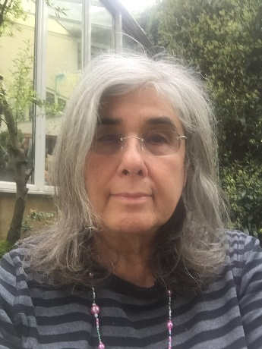

**Valerie Sinason**, PhD, is a poet, writer, child psychotherapist and adult psychoanalyst. She is also Director of the Clinic for Dissociative Studies, and specialises in working with abused/abusing and dissociative patients including those with a learning disability.

Valerie was Consultant Child Psychotherapist at the Tavistock Clinic from 1987 to 1999; Consultant Psychotherapist at both the Anna Freud and Portman Clinics from 1994 to 1997 and Consultant Research Psychotherapist/Psychoanalyst at St George’s Hospital Medical School, University of London, from 1994 to 2006. Valerie is Honorary Consultant Psychotherapist to the University of Cape Town’s Child Guidance Clinic.

Valerie is president of the IPD, Institute of Psychotherapy and Disability, patron of the Dorchester Trust and the Centre for Action on Rape and Abuse, acting chair of trustees of the Nieu Bethesda Arts Foundation and a council member for Norwood.

Her extensive writing includes over 100 published peer-reviewed papers, chapters and books. She has written over 12 books and 100 papers and lectures nationally and internationally. Her book titles include the seminal “Mental Handicap and the Human Condition” (originally published 1992; 2nd edition published in 2010 by Free Association Books), and “Attachment, Trauma and Multiplicity: Working with Dissociative Identity Disorder” (originally published 2002; 2nd edition published 2010 by Routledge). *Shattered but unbroken: Voices of triumph and testimony* (co-edited with Amelia van der Merwe) was published by Routledge in 2016. A recent volume in honour of her contribution to the field has just been published, edited by the late Alan Corbett. It is entitled *Intellectual disability and psychotherapy: The influence of Valerie Sinason* <https://www.routledge.com/Intellectual-Disability-and-Psychotherapy-The-Theories-Practice-and-Influence/Corbett/p/book/9781138323629>